**‘Wings’ J.J. Cahill Memorial High School**

***school newsletter***

|  |  |  |
| --- | --- | --- |
|  | **Address:**  **Telephone:**  **Fax:**  **Email:**  **Website:** | **Sutherland Street, Mascot**  **(02) 9669 5118**  **(02) 9667 4902**  [**jjcahill-h.school@det.nsw.edu.au**](mailto:jjcahill-h.school@det.nsw.edu.au)  [**http://www.jjcahill-h.schools.nsw.edu.au**](http://www.jjcahill-h.schools.nsw.edu.au) |

**‘Wings’ Issue 5 TERM 2 June 2013**

**EXCELLENCE RESPECT OPPORTUNITY**

TABLE OF CONTENTS

Principal’s Message Page 1

Deputy Principal’s Message Page 2

Library News Page 3

English/LOTE/Drama Report Page 4

Science/Maths Report Page 5

HSIE Report Page 5

CAPA/PDHPE/LS Report Page 6

Athletics Carnival Page 7

TAS Report Page 9

Yr 7 to Yr 12 Reports Pages 10-13

SRC Report Page 13

General Information Pages 14-16

PRINCIPAL’S MESSAGE

We are almost at the end of a short Term 2. All lessons will be taught up until the end of the school day on Friday 28 June. Year 12 students will conclude their Trial HSC examinations on that day as well.

CONGRATULATIONS

Fantastic news received recently. Brianna Seers gained third place in the regional cross-country carnival. That means she will go on to the State Cross Country competition. Congratulations to Brianna on a well-earned result.

REPRESENTING THE SCHOOL

It is timely for me to remind students and parents of requirements for any students wishing to represent the school. When students are nominated, a number of

COMING EVENTS

17-28 June – HSC Trial Exams

25 June – ‘Give it a Go’ Careers Day

25 June – Zone Athletics Carnival

28 June – Last Day Term 2

28 June – Student Reports Issued (Yr 7-11)

15 July – Staff Development Day

16 July – Students Return for Term 3

23 July – Yr 10 Subject Selection Parents Evening

24 July – Yr 10 Subject Selection Preparation UNSW

aspects are considered before approval is given. Their attendance needs to be at or above 90%, there should be no more than three instances of late arrival, they need to have a very good record adhering to the school’s uniform code (no more than two infringements) and behaviour needs to be exemplary. Any suspension results in a period of exclusion from representing the school (one week for every day of suspension).

Students in our Student Representative Council (SRC) who don’t meet this requirement may forfeit their place on the council. A warning regarding their continued representation will be issued with a formal caution.

canteen

Term 3 will see a new provider in the canteen. My thanks to the panel of staff members and students for their time and consideration of the many tenders the school received. I trust that our students will give their patronage to the new company to ensure they can continue to provide healthy and tasty food for our school.

uniform

The colder weather unfortunately sees a number of children wearing non-uniform items. Please ensure that school jumpers are purchased to keep your children warm. Girls now have long sleeved blouses available from Berelle. Our boys also need to be wearing ties for Terms 2 and 3.

A persistent problem and the source of complaints from both staff and parents is that some of our girls are hitching up their skirts or taking up the hem to unacceptable lengths. The skirt length should be 10cms from the bottom of the knee. This allows for some modesty particularly whilst walking up the many stairways around our school. Please make the necessary adjustments of the hems before returning to school next term. Girls may wear navy tights to keep their legs warm during the colder months. Navy beanies and gloves (not fingerless) are also permitted during the colder months. These, however, need to be removed when in classrooms. Navy ‘JJ’ scarves are available from the school and are the only ones permitted to be worn.

REPORTS

With the exception of the senior years, reports will be issued at the end of this term. I trust that students will respond to the feedback that they receive and focus on any shortfalls revealed. Years 7 and 8 should be doing approximately 1½ hours per night revising their school work, Years 9 and 10 up to 2 hours with Years 11 and 12 at least 3 hours per night, including homework and assessment task preparation. Sitting the Trial HSC will be a valuable experience for Year 12 students, highlighting where the gaps are in their knowledge which should then be a focus for subsequent study.

KEEP SAFE

I trust that all our families will have a safe and happy holiday break. School resumes for students on Tuesday 16 July. I look forward to a very positive and productive Term 3.

Robyn Cowin

Principal

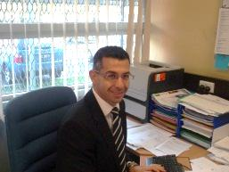DEPUTY PRINCIPAL’S MESSAGE

The school year is moving along very quickly and all students and teachers at JJCMHS have been extremely busy with school events and teaching, learning time culminating with a period of assessment for all students.

ATTENDANCE AT SCHOOL

One thing I would like to bring to everyone’s attention is the significance that consistent attendance has upon a child’s educational and social development. Under the Education Act it is compulsory for each child under the age of 17 to attend school. We at JJ support this Act and expect our students to attend school every day.

The Board of Studies has a requirement of 85% attendance in classes to satisfy course requirements. Falling below the requirement of 85% school attendance equates to an absence of seven school days per term. When a student has had more than seven days unexplained absence in the term they can be regarded as not satisfying course outcomes and requirements.

strategies offered by the school

The school has many strategies it offers students and families supporting school attendance. Year Advisors, the school welfare coordinator and the senior executive monitor student attendance closely, discuss relevant issues with students and help with strategies and implement attendance plans.

Sometimes simple advice such as changing sleep patterns, going to bed earlier, waking up to the sound of an alarm and avoiding watching TV of a morning are strategies that can help with punctual and consistent attendance. At present the attendance rates of many students are below state and school expectations.

HOME SCHOOL LIAISON OFFICER

The support services of a Home School Liaison officer employed by DEC also assist families with encouraging students to attend school on a consistent basis. However, the most effective and influential support a student can receive is the encouragement and help of their parents and carers.



did you know?

Being absent 1 day per week for a year is equal to 40 school days which is the equivalent of 240 school hours and nearly a whole school term. An absence of 2 days per week for a year is equal to 80 school days which is the equivalent of 480 school hours and nearly two school terms. This is also the equivalent of a whole year’s coursework.

Being absent from school has a direct impact on student learning and can cause gaps in skill development. The most effective and successful place for learning is to be at school and participating in class – every lesson, every day.

John Mifsud

Deputy Principal

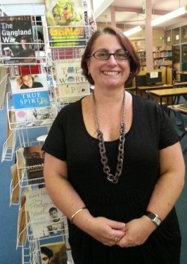library news

**Some of the library’s latest great reads!**

***Thai-No-Mite*** **by Oliver Phommavanh**

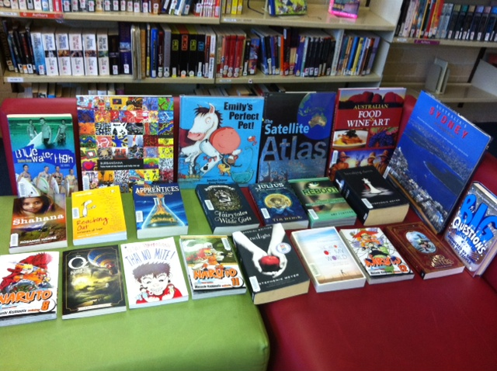I'm Lengy and I'm Thai. My parents run a restaurant named Thai-riffic! But I'm always craving hot chips and pizza. Mum and Dad's idea of a holiday? Going to Thailand to visit all our relatives.

Recipe for getting there?

* Survive Dr Needlemouse and his arsenal of needles
* Squeeze in a snappy budget trip to Dreamworld
* Catch a red-back spider for my Auntie
* Fight off a savage bat attack
* Celebrate Christmas, Thai-riffic style!

Recipe for surviving the planning?

A heap of good luck and plenty of THAI-NO-MITE! Phew! I'll need a holiday after this . . .

# ***Big Questions From Little People ... Answered By Some Very Big People* compiled by Gemma Elwin Harris**

# Children have a knack of asking great, but challenging, questions: Why is the sea salty? How far away is space? Why can't I tickle myself? What makes me *me*?

# But how are we supposed to answer them? Imagine if we could turn to a leading expert and ask them to answer on our behalf. This book gathers over 100 real questions from children and puts them to some of our best-loved and most knowledgeable experts.

# Alain de Botton explores 'How are dreams made?, Kate Humble explains 'Why do lions roar?' and Heston Blumenthal answers 'Why do we cook food?' Their answers to the Big Questions - some complex, some searching, some surreal and some just plain cute - make this an essential handbook for anyone who wants to understand the complexities of life, the universe and why cakes taste so nice.

# **Check out some of our other fantastic new resources in the library.**

**Watch out, there’s a pirate about!!**

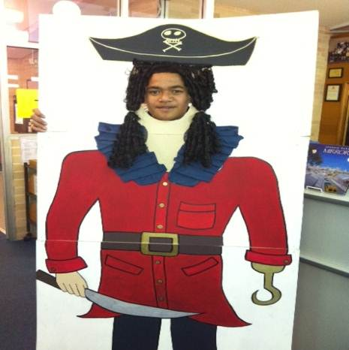

The library has been home to this art project by two students: Jazmin Stephenson and Charlie Mancini from Miss Hambly’s Year 11 Visual Arts class. The pirate is a statement of how easy it is to succumb to piracy with readily available information and ideas in this digital age. It has been a great learning tool to open up a discussion with students about plagiarism and the value of “All Your Own Work”. The pirate has also been a fun photo opportunity for students and staff! Thank you, Jazmin and Charlie.

**Artists in the library**

Thank you also to Danette Murillo of Year 7, as well as Jade Baugus and Madelyn Andrews of Year 8 for allowing me to use their magnificent *manga* inspired drawings as signs for the library’s *manga* collection.

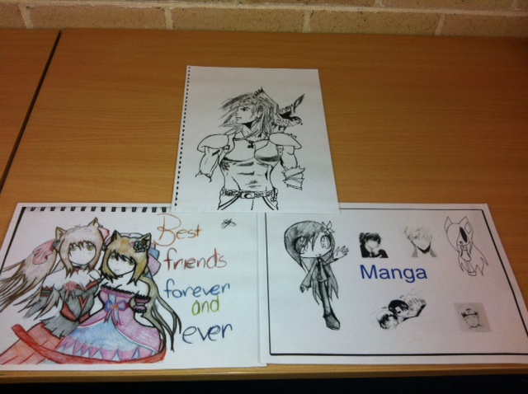

**Woolworths Earn & Learn**



As you know, our school has been participating in the Woolworths Earn and Learn program. The program has now finished for this year, so a big thanks to everyone who supported our school. We are now at the important stage of the program where Points Sheets are collected and lodged as our Earn & Learn claim. We will then be able to get new educational equipment for our school. The more we collect, the more we can redeem. So this week please send in your Woolworths Earn & Learn Points sheets and any loose Earn & Learn Points stickers you may have. Remember to check your handbag, the car glove box or they may be stuck on the fridge. Every little bit helps. Thanks again for all your support!

Julie Maddocks

Relieving Teacher Librarian

HOMEWORK CLUB

***Join us for Homework Club on***

***Monday & Wednesday afternoons***

***until 4.30pm in the Library!!!***

***All Welcome***



ENGLISH/LOTE/DRAMA REPORT

The HSC Trials are well underway and the Year 12 students have largely demonstrated a genuine effort to respond to the papers in a meaningful way. Well done to those students who came to school, asked questions and developed their understanding of the texts studied in order to achieve their best. You know who you are!!!

To our HSC Drama students, Term 3 is a big term for you. Work hard on your Individual Projects and encourage each other to strongly develop your Group Projects. Work together, be a team and be creative.

To our HSC French class, faites les études durement, pratiquez votre facilité et prononciation et appréciez la belle langue qui est le français.

Year 11 students need to be studying for their assessment tasks, which will be conducted early in Term 3. Half an hour a day would really help in their preparation. This will leave the rest of the day for other things.

I have read the reports for all students for this semester. I congratulate those students who have engaged with the learning in class and recognise that their teacher is *their* partner in education and in *their* success. I encourage you to continue working with us to ensure you achieve your goals and that your education is a positive and meaningful experience.

I also encourage those students who have not achieved to a satisfactory level to ‘check in’ with your teacher and build a strong learning relationship. This will only benefit you and your success.

Next Term will see the production by Year 11 of their major dramatic work. These students have been involved in all aspects of dramatic production; script work, directing, costuming, blocking out scenes etc…. Keep an eye out for when the show is on and come and support our Year 11 Drama students showcasing their talents.

Congratulations to Mr De La Hoz, our practicum student from the University of Notre Dame. He has successfully completed his major practicum experience and I hope his time at JJ was an excellent learning experience that will ensure his success as a fully qualified teacher in the years to come.

I wish everyone in our JJ community a safe and happy holiday.

David Gracie

Head Teacher English/LOTE/Drama/Library

SCIENCE/MATHEMATICS FACULTY

The Mathematics and Science faculties would like to congratulate all students who have recently completed their Half Yearly Examinations. A special mention goes to Yusuf Nayir, Isaac Real and Tilani Hardy who scored over 90% in their half yearly Mathematics Examinations. A great achievement!

Additionally, we would also like to congratulate Miss Griffith’s Year 10 Science class who used their critical thinking skills to design parachutes, taking in to account wind resistance, surface area and other forces which could affect flight time. The students had a wonderful time designing their parachutes and there were features such as large canopies and wings. The

students were impressed at how they could apply their knowledge of forces and motion to ensure that their

parachutes safely and slowly reached the ground. It was great to see our students applying their knowledge and having so much fun in the process!

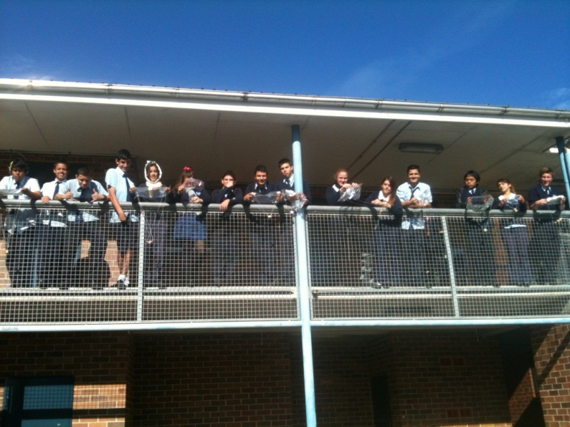

*Miss Griffith’s Year 10 class watching their parachutes flying.*

Megan Griffith

Relieving Head Teacher Maths and Science

HSIE REPORT

keep working hard

Now that the junior years have recently finished their exams, it is a good time for students to reflect on what they have learnt throughout the year and think ahead for the rest of the year. All our students need to realise that learning is a continuous process which requires a consistent effort over a long period of time. This means that exams are not the end of hard work. As the Year 12 students sit down for their trial exams this fortnight, they know that it takes over 2 years of solid learning in order to achieve good results. So to the junior students keep going, aim for your personal best every time you complete a task, one step at a time. To the Year 12 students: stay strong with your study and preparation as you are very close to completing the final hurdle.

WORLD ENVIRONMENT DAY

On the 7th of June, it was World Environment Day and I would like to make you aware of an important fact. The first is that the amount of carbon dioxide on planet Earth has recently reached a tipping point regarding its concentration in the atmosphere we breathe. This means that little by little the life we are all living is contributing to a place where in the future our grandchildren may not have the same quality of life as we have today.

This is due to the impact on the climate. So I encourage you all to reflect on a small thing that you can change in your life to try and reduce the impact you might have on the future. It might mean walking to the shops or lowering the temperature on the heater by 1 degree or having a shorter shower – everything makes a difference.

MR DRABSCH’S GARDEN BEDS

On a related note, I would like to bring your attention to the work that Mr Drabsch has been putting into the small garden space we have at JJCMHS. His Support Unit class has made two garden beds and planted beans and carrots.

In addition he has started two compost bins and recently a worm farm to gain fertiliser for the garden. The support unit and HSIE staff have been placing their food scraps into these recycling units to further assist.

Whilst it is winter there is not a lot of growth, however, with the care of the support unit students, by the end of spring, it should be flourishing.

Mr Sutton

Head Teacher HSIE

capa/pdhpe/learning support faculty

There are many exciting things happening in the faculty at the moment, and much in store for the future!

LOTS OF EXTRA-CURRICULAR ACTIVITIES

The Creative And Performing Arts (CAPA) staff continues to support a range of extra-curricular activities within the school. Visual Arts (VA) teachers have begun an Art Club, which runs after school on Wednesdays, which is a space for elective VA and photography students to build on class work and develop new skills in a variety of artistic forms. Ms Ferguson has had a number of students attend but more are always welcome.

Coming up in the Term 3 will be the annual JJCMHS Art Show at Mascot Library. It promises to be another great show. Also beginning in Term 3 will be the JJ Big Band. Mr Fienberg has had many students express an interest in this exciting opportunity and it will be great to see what unfolds. JJ's Dance Group is also up and running during Monday lunchtimes.

BAND REPORT

On Wednesday the 19th of June, students and parents gathered to discuss the commencement of the JJ Cahill Memorial Big Band. Here students had the opportunity to trial the instruments and ask questions about the program.

Lessons and band rehearsals will be commencing in the first week of next term. The band will be working on a performance for the Big Night Out. If you would like to be a part of the band please collect an information slip from outside the front office. The Band Fee Payment of $100 will need to be paid in full before instruments can be issued.

LEARNING AND SUPPORT TEAM

The Learning and Support Teachers have been working with a range of students both in and out of classes to assist them with their learning. This includes facilitating special provisions for a number of students during the Year 10 Half-Year and Year 12 Trial examinations. Their efforts are greatly appreciated.

Meg Hallahan

Head Teacher CAPA/PDHPE/Learning Support

Sports report

On Wednesday 12th June, JJCMHS held its athletics carnival at Hensley athletic field. The day started dry, however by 10.30am the rain closed in which prevented events to run in safety. As a result the carnival was cancelled and students returned to school for an afternoon of activities and a sausage sizzle. By 2pm the sun was shining again and students had a smile on their faces. Students were invited to nominate their interest in all events that were not run at the carnival, and if there were more than two competitors in each age group for each event, these events were run at school on various days to decide the students who compete at the zone.

THANKS EVERYONE!

Thank you to all students who attended the carnival and congratulations to all the competitors and best of luck to those who will be attending the Eastern Suburbs Zone Athletics Carnival Hensley Athletics Field, Pagewood. Please note that this has been postponed until 26th July due to the wet weather.

Nathan Potter

Sports Co-Ordinator

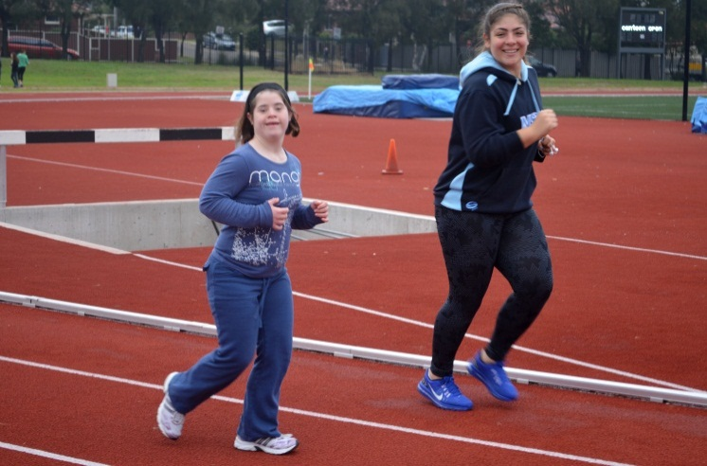

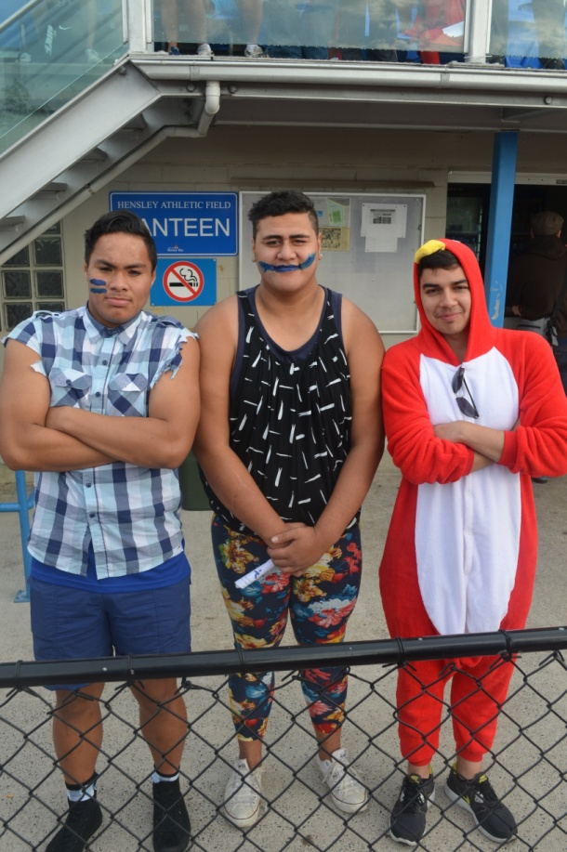

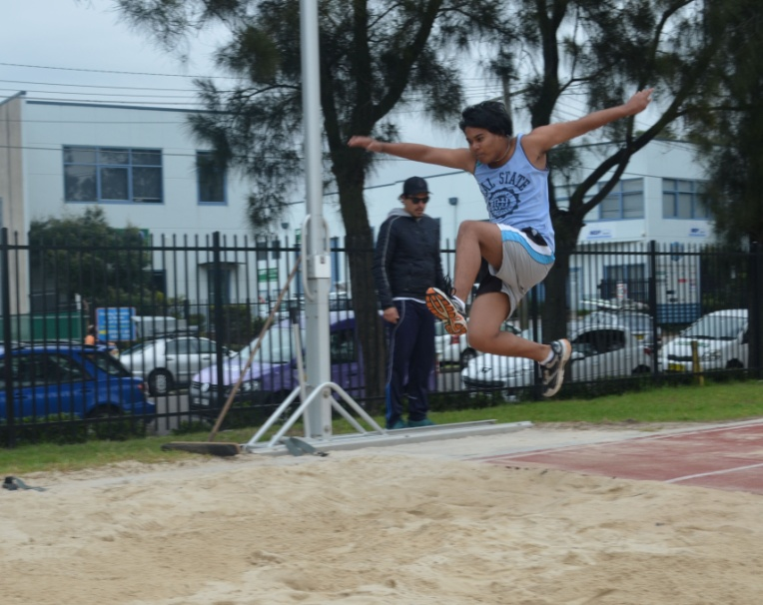

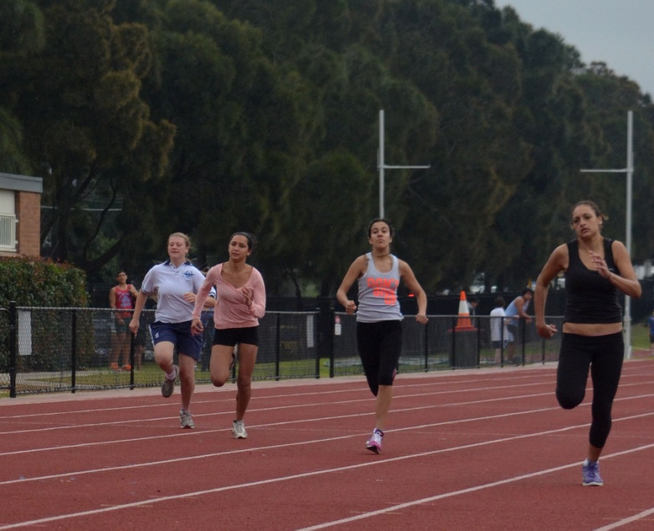

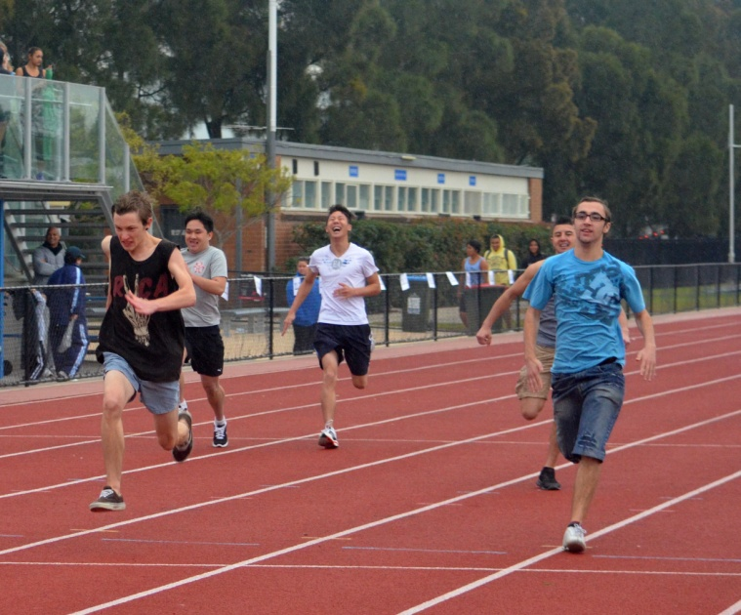

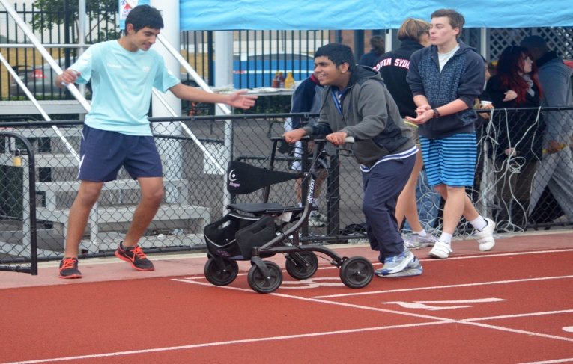

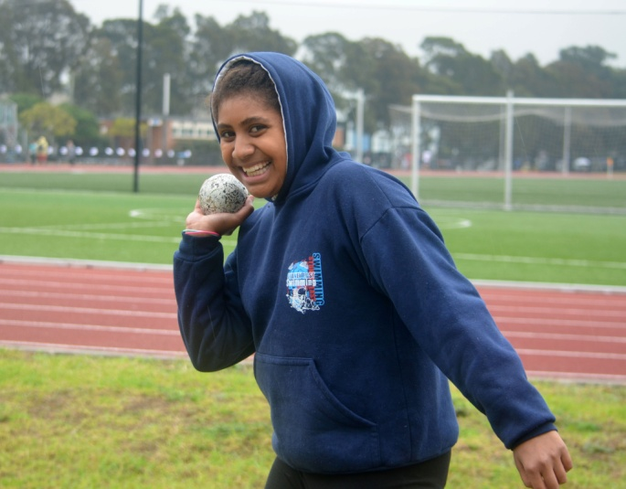

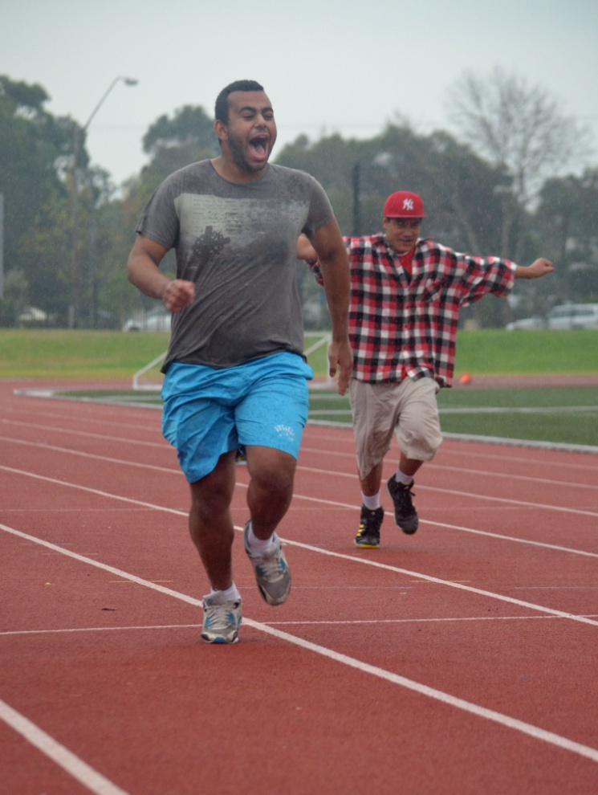

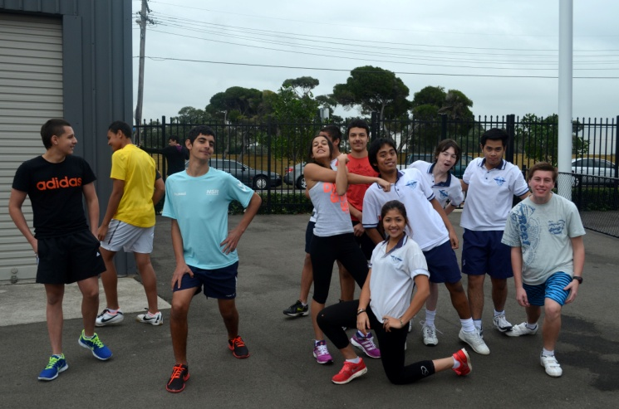

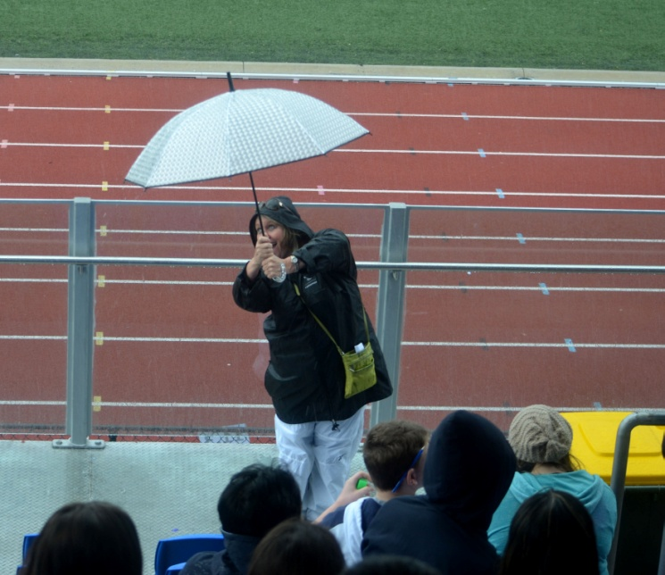

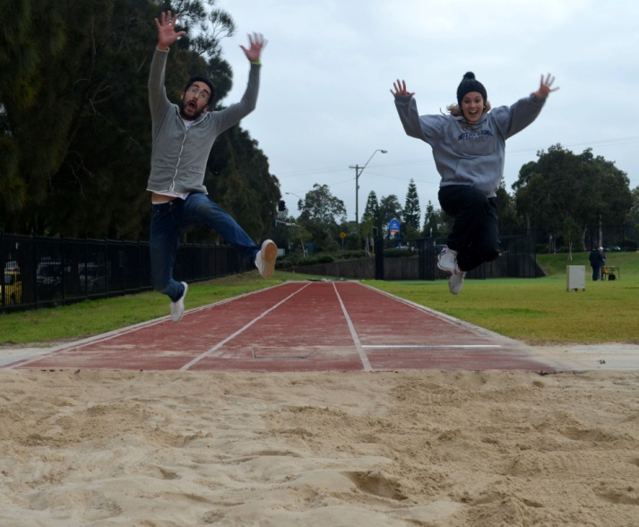

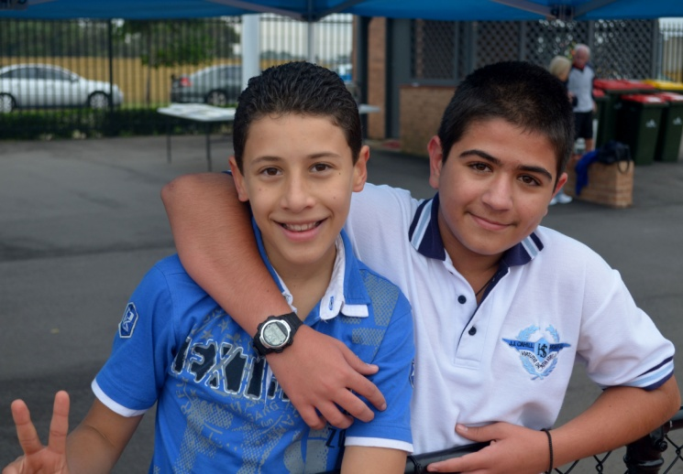

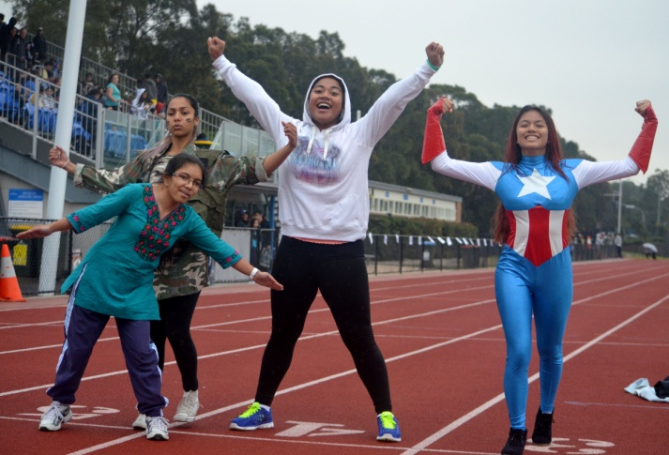

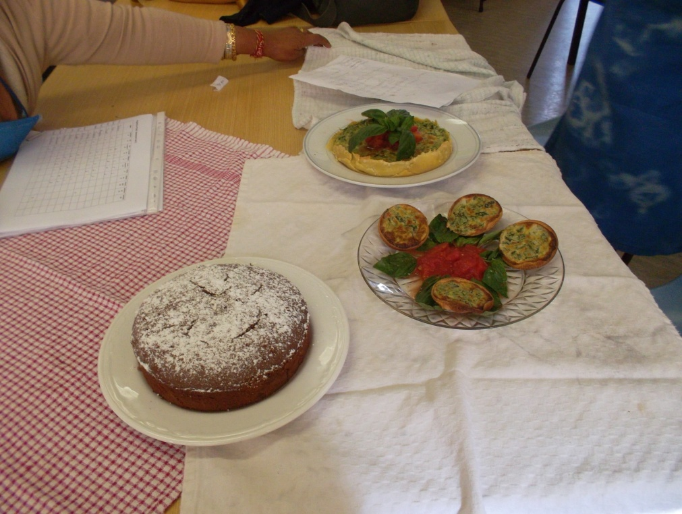

tas report

Joanne Alzate, Faaleiloa Polamalu and Trent Carroll of Year 11 recently created the following menu as part of their “Properties of Food’ assessment task.

Underneath the menu is a picture of the finished meal!

Menu

Entree

Bruschetta

With olive oil, vine-ripened tomatoes, garlic, basil and egg on top

Main Dish

Spice-crushed Lamb Cutlets with Mash Potatoes

Sweet and spicy, these juicey lamb cutlets will delight your taste buds.

Dessert

Vanilla Poached Pears

With ice-cream on the side.

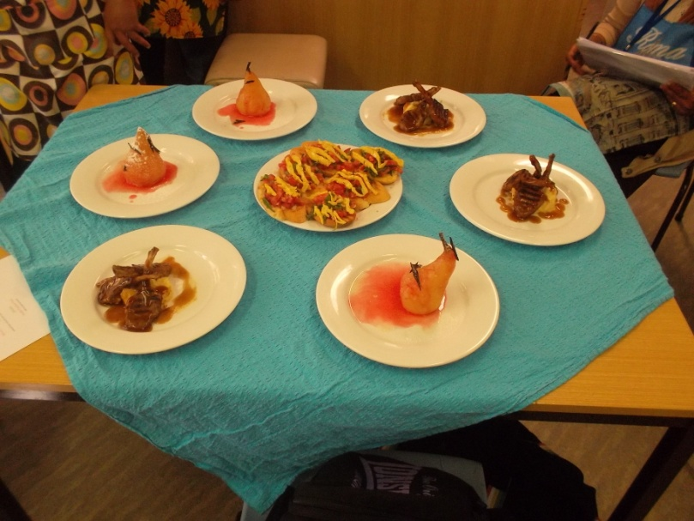

Bhagwati Prasad

Teacher, TAS

*(Above) another great meal cooked by Year 11 and (below) Year 7 cooking aprons.*

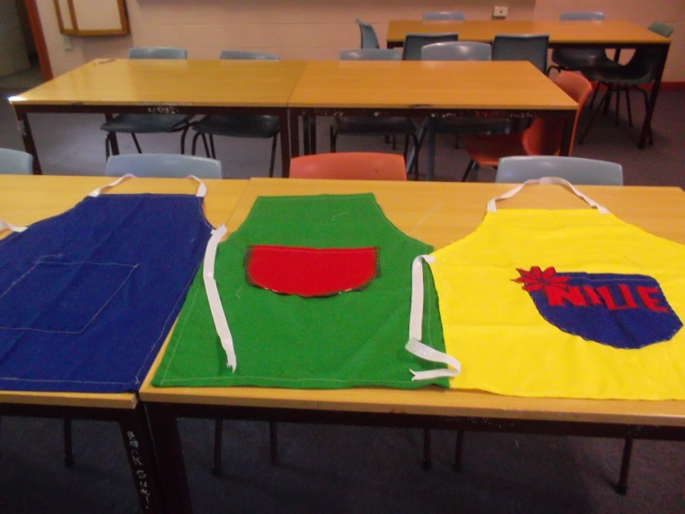

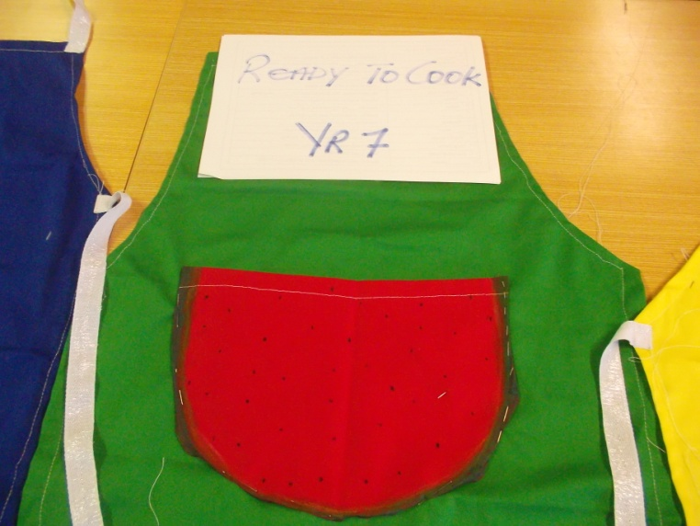

WELFARE notice

student health plans

**A reminder to parents to notify the school about your child’s health**

We welcome information from parents about your child's health, even if you are not requesting specific support from our school. Our school asks for medical information when you enrol your child. It is also important that you let us know if your child’s health care plan needs change or if a new health condition develops.

Information about allergies, medical conditions such as asthma and diabetes and other health care related issues (including prior conditions such as medical procedures in the last 12 months) should be provided to the school by parents. Please provide this information in writing to the principal*.* This will greatly assist our school in planning to support your child’s health and wellbeing.

Please also remember to notify staff in the school office of any changes to your contact details or to the contact details of other people nominated as emergency contacts.

We appreciate your assistance in this regard and assure you that any information you provide the school will be stored securely and will only be used or disclosed in order to support your son or daughter’s health needs or as otherwise required by law.

Loukia Panayiotou,

Welfare Co-ordinator

YEAR 12 REPORT

With Trial HSC Exams in progress, Year 12 students are busy studying and preparing for a large component of their internal assessment marks. To help prepare for this stressful experience, Year 12 participated in a study and wellbeing day coordinated by JJ Cahill teaching staff and counsellors from across the region. Here they were exposed to different study techniques and coping methods that will prove invaluable in the coming months.

It is critical that all Year 12 students continue to study over the holiday break. While a short rest is well deserved, students will need to make the most of the extra time to refine major works and consolidate notes made for trials. Upon return, thorough evaluation of results will be needed to develop new goals for the external exams.

With only one school term to go, I encourage all students to make the most of their time to ensure that they give themselves the best possibility to succeed.

Mr Fienberg

Yr 12 Year Advisor

YEAR 11 REPORT

It has been another busy term for Year 11, with a lot of activities happening both in and out of school and, being a 9 week term, it has felt like the whole term has been on fast forward. There have been a number of excursions, activities, performance evenings and workshops that have all been great successes and this is due to both the fantastic attitude and willingness to be involved on the students’ behalf and the hard work and dedication of the teachers to provide amazing extracurricular opportunities in which our students are able to thrive.

REPORT REFLECTION AND GAINING FUTURE DIRECTION

At the beginning of this term I had the pleasure of interviewing all Year 11 students in small groups to take them through a reflection process, looking at where they finished in Year 10, how they are currently travelling in their Preliminary studies and looking forward to the future to begin looking at making goals, developing a plan and gaining focus on what needs to be done in order to achieve.

In every group session the students were outstanding and I thoroughly enjoyed gaining a strong insight into

the thoughts and reflections of our students. As their year adviser, I was very inspired listening to the goals that our students have and was really pleased to hear how much the students are connected to their future, having a clear awareness of the things that need to be done to ensure they reach their goals. Mr Potter (Careers Adviser), Mr Sutton (Head Teacher, Year 11), Mr Mifsud and I are all in constant conversation about putting things in place and organising opportunities for Year 11 so that in the year ahead our students will have every opportunity they need to access their desired direction.

performance evenings

Mr Fienberg and Mr Jobe have been working tirelessly with our performance students both in and out of class time to ensure our students skills are developing and being refined. On separate occasions both teachers have organised Year 11 performance evenings for the students to practise the skills of performing to an audience in a professional manner.

I unfortunately missed the Drama evening last term but I was glad to make it to the Music evening where I witnessed some outstanding performances. It was very clear to see the dedication that Mr Fienberg has put into the education of these students as I saw one who were once very shy, introverted people, stand with confidence and deliver a beautiful performance. I also want to thank family and friends who support the students by attending these evenings. I know how much they love when they can perform for you. Your continual support is much appreciated.

LEADERSHIP WORKSHOPS

In Week 6 a group of staff ran a leadership workshop for a selected group of Year 11 students. These students were individually selected by a group of teachers and were chosen in recognition for the leadership skills and qualities they display across a range of different areas.

We selected students who display leadership qualities within the school, as a representative of the school, in the playground, during sporting matches, in the arts and also within their peer groups. It was great to have such a diverse group of students and they all brought something unique and individual to our workshop. The students attended the workshop with outstanding enthusiasm and willingness to participate and it was really special to watch this group of students

demonstrate exactly why they were selected in the first place. During the workshop we looked at areas such as: what makes a good leader, what qualities does a leader display, working as a team but taking initiative to promote good teamwork, examples of leadership across different contexts and strategising how we can show leadership in our school, in our community and in our lives. At the conclusion of the workshop all of the teachers involved spoke of the maturity and positivity displayed by all students and how inspired they were to present and work with such a great bunch of young people. I have attached some photos for you to see some of the activities and fun that was had during the afternoon.

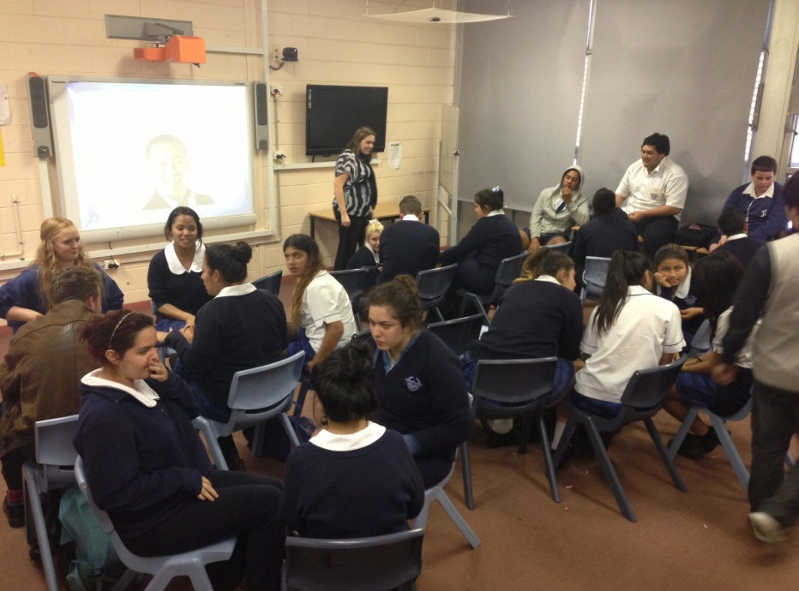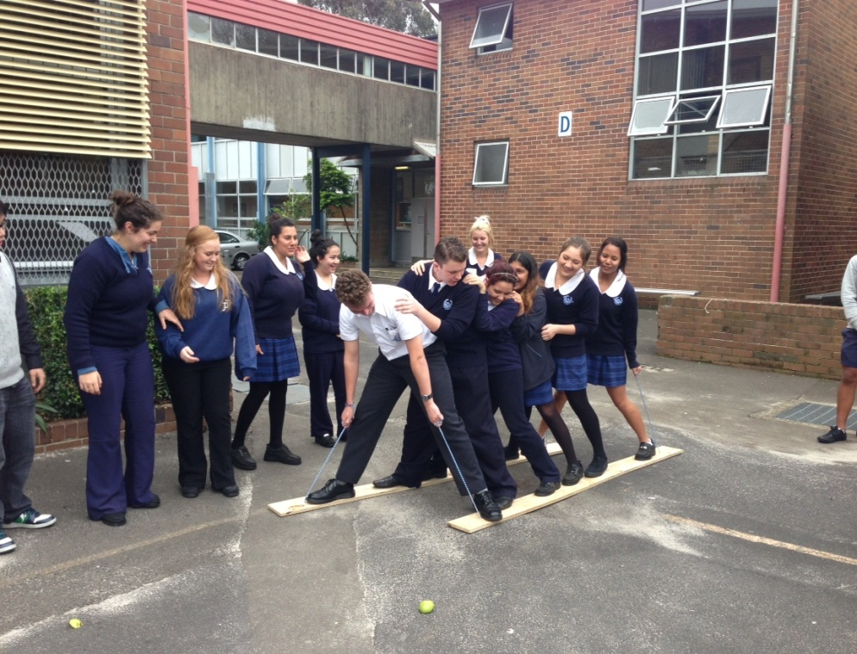

*Year 11 leadership workshops.*

There has been a lot going on and this, combined with all of the hard work that has been occurring in the classroom, has made it a very busy time indeed. As we head towards the end of the Preliminary studies, attendance,  consistent application, conscientiousness and diligence are all vital components our students must endeavour to maintain to ensure they give themselves the best opportunity to achieve personal best.

At the end of Term 3 our students move into the HSC year of studies and I hope they can maintain the great momentum they have developed this year using it to lead them on to bigger and better things ahead.

Have a great break, and please encourage the students to revise and study so that they are well prepared for final exams next term.

Amber Housego

Year 11 Adviser

YEAR 10 REPORT

This has been such a busy term! Consisting of only nine weeks, and with lots of (welcome) interruptions such as the Queen’s Birthday long weekend, the athletics carnival and the cross country carnival, it seems like time has flown by!

It won’t be long before Year 10 will be making those all-important subject selections for their senior studies. I hope that all students are starting to seriously think about the subjects they would like to study in Year 11 and 12. Remember that seven terms is a long time to be stuck with subjects that you really do not enjoy, or struggle with in terms of natural ability and interest, so it is important to choose wisely!

While it is crucial to choose subjects according to the future career path a student may have in mind, it is also important to be realistic. Don’t choose subjects just because your friends may be choosing them or because you think a particular teacher might be taking that subject. It is more important for you to realistically evaluate your strengths and weaknesses: if you struggle with writing then you might like to limit the

amount of essay-driven subjects you choose: if maths is your weak point then you might be best to avoid subjects which require a strong degree of mathematical ability. It is important to talk to your teacher if you are uncertain about these issues, and to be prepared to heed the advice they give you!

Another important point of consideration is, of course, your future career path. If you are lucky enough to know what you would like to do when you finish school, it is very important to tailor your subjects accordingly. Many university courses require prerequisites such as Maths or a certain level of English, for instance. It is relatively easy to find out this kind of information – you can look up the universities online or simply have a chat to our careers adviser – Mr Potter!

Katherine Doret

Year 10 Adviser

YEAR 9 REPORT

As most of you would know by now, I have taken over the role of year adviser for Year 9 while Mr Cohen is on leave.

I would like to say to Year 9 to please feel free to come by the Maths/Science staff room at any time if you have any

concerns or to ask for advice as I am getting to know you all and work with you in achieving your academic goals.

Term 2 has certainly been a busy time for both students and teachers. Year 9 sat for their half yearly examination in Week 5, followed by Year 10 and Year 12 are currently sitting for their trials. It was also great to see so many Year 9 students participating in the sports carnivals and other extra-curricular activities during Term 2.

On another note, the school would like to thank all the parents who have paid the fees for Year 9 electives and encourage parents who haven’t paid to continue to do so.

I am in the process of reading all your reports at the moment. Please ensure you read the comments carefully and heed the advice of all your teachers in planning for Term 3 at school. I wish you all the best for a restful winter break and keep safe and well. Please use this time to also prepare yourself with all the necessary equipment for a successful start to Term Three.

Abraham Berakhi

Year 9 Adviser

YEAR 8 REPORT

As we reach the end of Term 2 it is not hard to acknowledge how quickly the weeks have flown past! There has been a lot going on this term, and as always it is great to see such positive progress for many Year 8 students. Congratulations to those students who have been involved in representative sport, including knockout and grade sport, and a shout out also needs to go to the Year 8 SRC representatives for their ongoing commitment to the whole school community.

At the end of this term reports will be issued to all students, and it has been wonderful to hear so many positive comments as well as constructive feedback for Year 8 students from their teachers. There has been some very promising progress made some students, and I am sure this will continue as the year progresses.

I hope Year 8 as a whole will continue to make effective choices regarding their learning and take on board the feedback from their teachers when they come back next term.

The second half of the year promises to be busier than the first, as Year 8 is on the eve of their subject selection for Year 9. With more information to come in the coming months, I look forward to chatting to many students and their parents about these important decisions.

Have a safe and happy holiday break.

Kristy Dawkins  
Year 8 Adviser

YEAR 7 REPORT

Now that Year 7 have had a full semester of high school, it is safe to say that they have settled in fantastically. As a year adviser it is pleasing to receive consistently positive feedback regarding the general approach and attitude of Year 7 towards their studies and each other.

A key focus for Year 7 so far this year has been to accept and embrace the opportunities presented to them. It is fantastic to see such a strong representation of Year 7 students in our newly formed Dance Group as well as our school choir. Both of these groups are preparing to feature in the Big Night Out next term so I am very excited to see a range of Year 7 talent on show.

Early in the term all Year 7 students were offered the chance to audition for Channel 9’s television program, ‘Kitchen Whiz’. The vast majority of students took up this opportunity and I am pleased to announce that 12 of our students will be involved in the filming of episodes at a genuine television studio at Fox Studios in Moore Park. I will keep you advised regarding the dates we can expect to see these JJ students grace our screens.

Keep up the good work Year 7.

Curtis Jobe

Year 7 Adviser

SRC REPORT

Students may not be aware that the SRC have formed committees in important areas around the school. We work together with teachers and parents and make informed decisions on behalf of our fellow students. The members are selected carefully and there is strong

emphasis on individual interests and passions. For instance, Gregory Patakos has a white card and this is very useful for this committee.

Most recently our canteen committee assisted with valuable feedback and advice with the view of a good outcome for our school.

The Work Health Safety (WHS) committee meets regularly to discuss school policy and issues in our school environment.

We have had representation on our school uniform committee for the past two years and have seen changes that have enhanced our image. The committee takes its role seriously and our input is always considered by parents and teachers alike.

Finally our SRC Zone committee members represent our school with pride at regional meetings. The members attend once a term and it’s an opportunity for them to share ideas and learn from each other. Special guests speak on many interesting and topical subjects, currently the topic is Sustainability.

The Global Leaders Convention was attended again this year by Year 12 delegates and we will feed back to Mrs Dawkins’ Year 11 class: more news on this soon.

Yusef Nayir from Year 10 is keen to be Director General for a Day, so good luck!

And most importantly, please congratulate Ciaran Bastick on going to Youth Parliament in the holidays. Thanks for representing us, Ciaran.

Thanks JJ

Victoria Kafavalou

SRC President

[](http://www.google.com.au/imgres?imgurl=http://www.digitalalchemy.com.au/uploading/Client_Logo/NRMA.jpg&imgrefurl=http://www.digitalalchemy.com.au/Our_Community/?contenttype=29&usg=__T6N80T0hSFtg9fEh2onH5b1fw4k=&h=639&w=840&sz=98&hl=en&start=12&zoom=1&tbnid=aykjx6divmZQ6M:&tbnh=110&tbnw=145&ei=XunIUYvNEY7NkQWltIGgBg&prev=/search?q=NRMA&safe=active&sa=X&tbm=isch&itbs=1&sa=X&ved=0CEIQrQMwCw)

NRMA Motoring & Services recently launched its ‘Keep School Zones Safe’ Survey. The purpose of this survey is to obtain information on the number of 40km/h school zone signs and road markings that are faded or obscured by trees or poles. You are encouraged to participate in this short internet based survey to help the NRMA improve safety around schools. Anyone can complete the survey.

The survey contains just six questions and allows respondents to upload photos of the signs and other safety features at their school zone.

The survey will remain open until the 29th July 2013.

School zone signs were first installed in NSW over twenty years ago and many signs are now well past their use by date.

In 2009 NRMA successfully campaigned for the standard yellow school zone sign colour to be upgraded to a much brighter fluorescent yellow green. This colour really stands out and can be seen twice as far away as the standard yellow signs.

The NSW government has committed to upgrading all faded signs. The feedback from this survey will provide NRMA with vital information which will aid us in ensuring that the upgrade of school zone signs is completed so that we can ‘Keep School Zones Safe’.

If you have any queries about this survey, please contact Jonathan Hennessy, Policy Advisor – Traffic Projects, NRMA Motoring & Services on 02 9276 7219 or [Jonathan.Hennessy@mynrma.com.au](mailto:Jonathan.Hennessy@mynrma.com.au).

To complete the survey please visit [www.mynrma.com.au/schoolzonesafety](http://www.mynrma.com.au/schoolzonesafety).



***WOMEN’S COURSE!***

Refresh your skills and build the confidence to apply for the job you want...to pursue further study...to make a change!

Certificate II Skills for Work & Training for Women includes a Work Experience program, Computing, Communication, Workplace Writing, Interview Skills and more.

Classes are within school hours for 18 weeks in a friendly, supportive environment.

This course is fee exempt - $30 materials fee only.

Childcare may be available on campus.

Close to Central train station. Student discounted parking nearby.  
Course commences: 15th July 2013.  
Information session:  
11:00am Monday 24th June 2013  
Building D, 5th Floor, Room D5.10  
Ultimo TAFE College

Corner Thomas St & Harris St, Ultimo

**Enquiries**: phone 9217 3724 or 9217 3718

email: [anna.petrou@tafensw.edu.au](mailto:anna.petrou@tafensw.edu.au)

